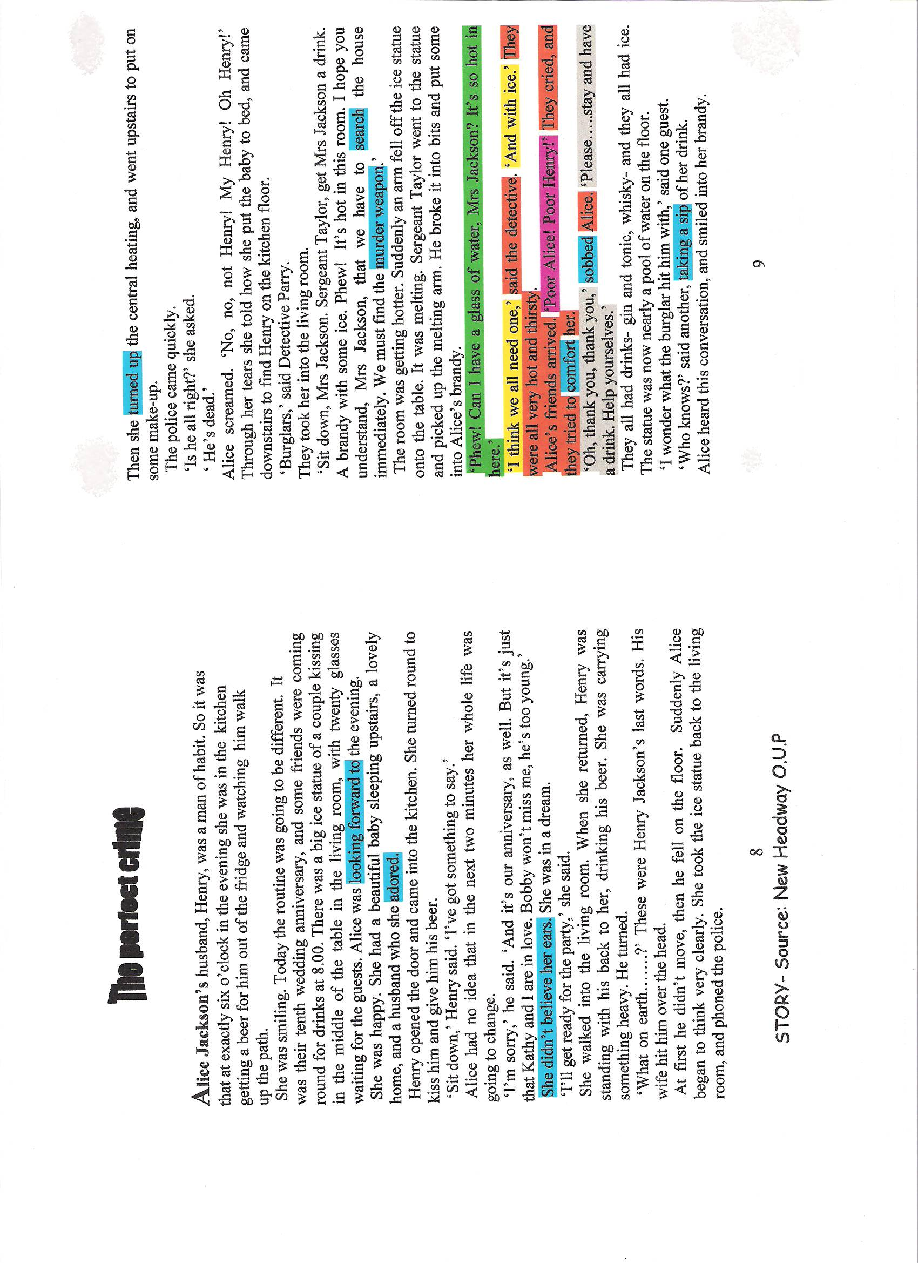
Oxford Press Order the pictures in the way the story happened.
Justify your reasons.
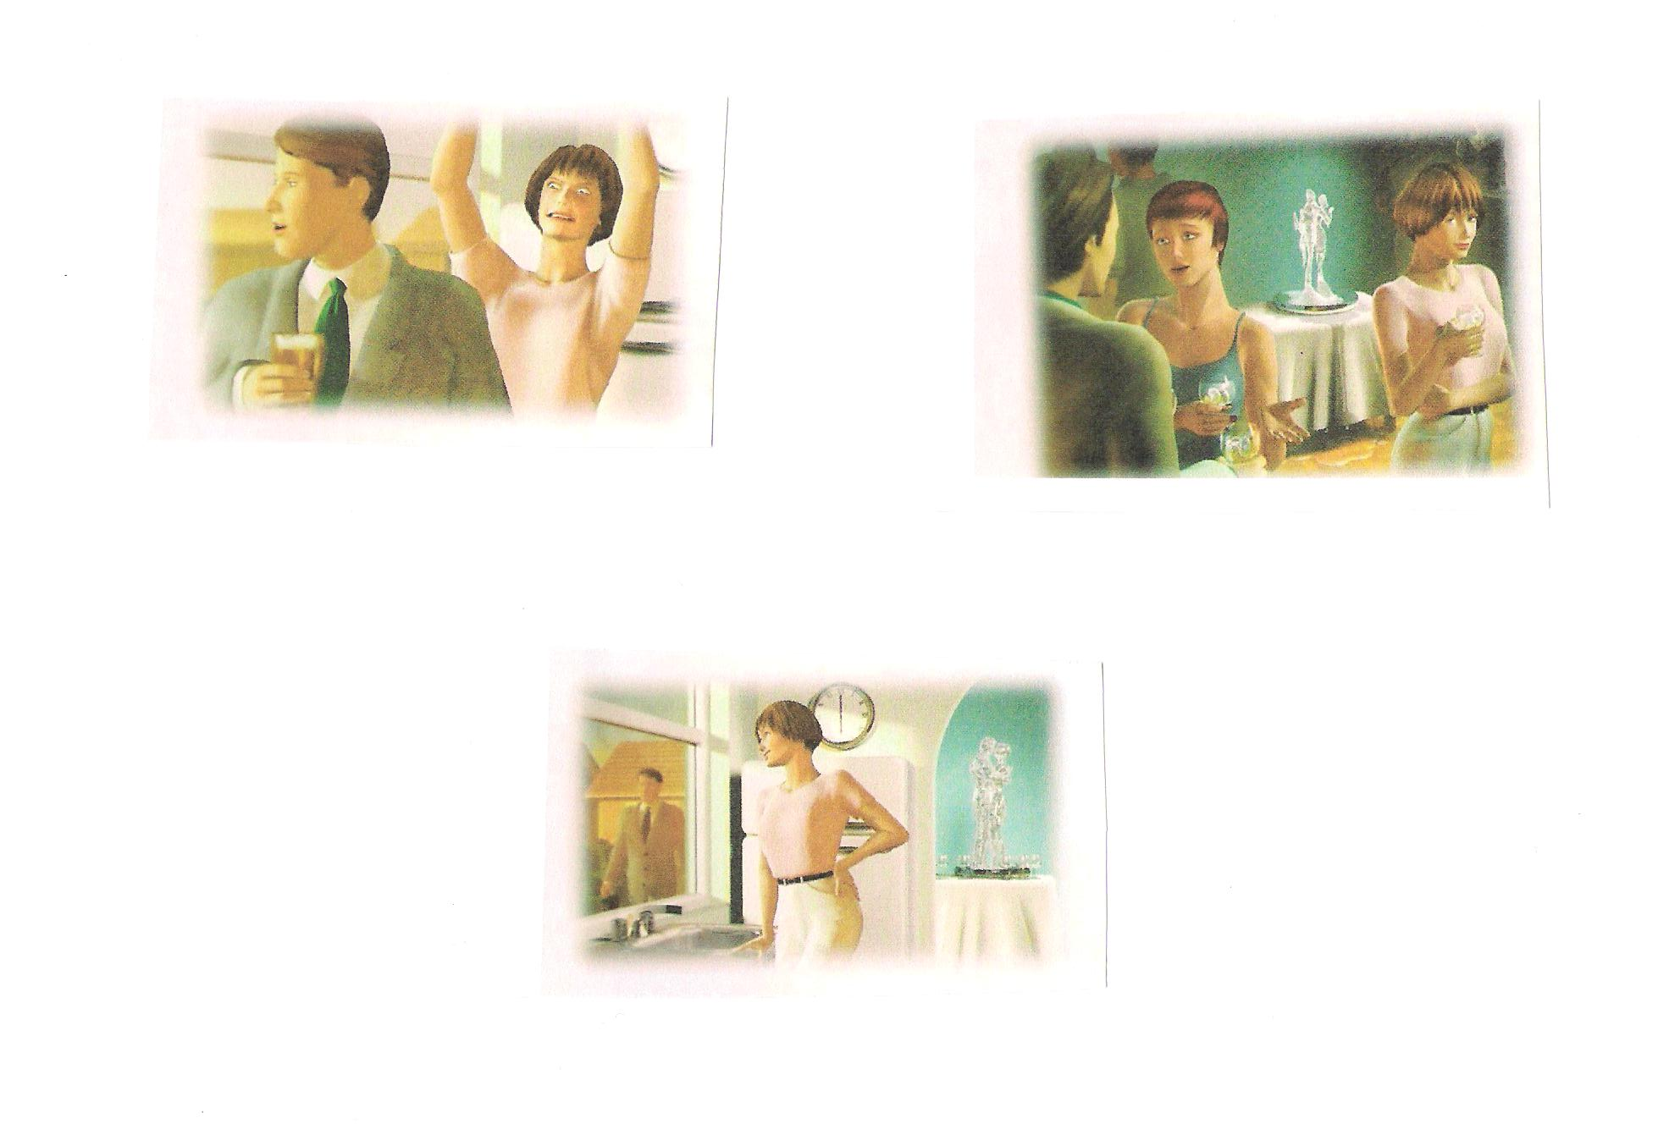
Source: New Headway- PreIntermediate.

HANDOUT 1
●Match the headings to the correct boxes.

●Making suggestions ● Reformulating your words (when the listener hasn’t understood)
●Agreeing with someone ●Asking for Opinion ●Asking for repetition
●Interrupting ●Expressing Opinion ●Disagreeing Politely
●Giving reasons

1. | 2. | 3.
●I think…..  ●I feel that…. | ●What do you think about….?  ●Do you think that……? | ●Yes, that’s right.  ●I think so, too.
4. | 5. | 6.
●I see what you mean, but…  ●I don’t think so | ●I think…..is right because….. | ●Sorry, what was that again?  ●Would you mind repeating that?
7. | 8. | 9.
●Let’s start with…  ●Why don’t we…? | ●What I said was…… | ●Sorry to break in, but…  ●I’m sorry to interrupt…

Well…..

Actually…

I SEE WHAT YOU MEAN.

NOW LET ME THINK………………….

I’LL HAVE TO THINK ABOUT IT.

NOW, WHERE SHOULD I START….

